Market Research Analysis for the Hyperlocal Disaster-to-Commerce (D2C) Mesh Platform — Nakhon Pathom, Thailand

Executive Summary
The D2C Mesh platform targets a genuinely unoccupied market position in Thailand’s disaster-response ecosystem. Despite substantial national investment in flood monitoring — spanning TMD weather forecasting, HII’s 4,000+ telemetry stations, GISTDA satellite mapping, and the newly launched One Map Water dashboard [1] — Thailand’s State Audit Office found that 72.31% of flood incidents between 2021 and 2024 occurred without prior warning, and nearly half of at-risk villages lack warning stations entirely [2]. No existing Thai or global platform integrates hyperlocal street-level flood prediction with vehicle-aware routing and automated relief disbursement into a single warning-to-action pipeline. Floodboard.org offers partial vehicle passability data but lacks predictive capability [3], while navigation platforms like Google Maps and Longdo Map incorporate no real-time flood data into routing algorithms.
The platform’s most strategically compelling advantage lies in Thailand’s already-mature digital payment infrastructure. PromptPay processes over 74 million transactions daily with near-universal merchant QR acceptance — including street vendors [4, 5] — eliminating the merchant-onboarding barrier that stalls humanitarian voucher programs elsewhere. The Khon La Khrueng co-payment model, delivered through Krungthai Bank’s Paotang app to 40 million users [6], provides a proven architectural template for the e-voucher system, and Krungthai’s Open API portal now enables third-party integration [7]. Global precedents from WFP Building Blocks and Oxfam’s UnBlocked Cash confirm that vendor-integrated digital vouchers outperform traditional relief distribution [8, 9].
The strongest year-round sustainability opportunity is serving as the digital disbursement layer for Thailand’s approximately 7,800 Local Administrative Organizations (อปท.), which hold fiscal autonomy but lack any standardized digital welfare distribution platform [10]. By routing อปท. welfare vouchers through PromptPay-integrated local merchant networks during non-flood seasons, the D2C Mesh can maintain continuous user engagement and merchant participation — transforming seasonal disaster infrastructure into permanent community commerce rails.

Introduction: The D2C Mesh Concept and Research Scope
Thailand’s disaster response ecosystem is characterized by fragmentation — flood warnings, evacuation routing, and relief distribution operate through separate agencies, platforms, and workflows with minimal real-time coordination. The Hyperlocal Disaster-to-Commerce (D2C) Mesh platform proposes to bridge these silos through a three-track integration: AI-driven hyperlocal flood early warning using public APIs from the Thai Meteorological Department (TMD), GISTDA, and the Royal Irrigation Department; vehicle-aware dynamic routing based on real-time flood depth estimation; and a decentralized E-Voucher system enabling government and donor funds to flow directly to flood victims for redemption at nearby safe SMEs designated as “Micro-Relief Stations.” Planned for pilot deployment in Nakhon Pathom province, the platform is designed to transition into a year-round Community Commerce and Local Welfare Hub during non-flood seasons, leveraging อปท. (local administrative organization) welfare vouchers and PromptPay integration.
This market research, conducted for the ideation phase of the AI for All Thailand Innovation Sprint hackathon, examines four critical dimensions: Thailand’s existing flood warning and routing landscape, global decentralized disaster relief and e-voucher technologies, Thai government digital welfare infrastructure, and the strategic white-space opportunities that position the D2C Mesh as a differentiated solution. The findings reveal a market where individual components — sensors, payment rails, welfare apps — are increasingly mature, but no platform integrates them into a coherent warning-to-action-to-relief pipeline.

Thailand’s Flood Warning and Monitoring Landscape
Thailand operates a multi-agency flood monitoring ecosystem that has recently undergone significant consolidation. The Thai Meteorological Department (TMD) serves as the official warning authority, providing weather forecasts, heavy-rain warnings, and storm tracking through its Thai Weather app, though its focus remains on regional-scale meteorological conditions rather than street-level inundation [11]. The Hydro Informatics Institute (HII), operating through the ThaiWater platform, consolidates data from over 4,000 telemetry stations covering rainfall, river and canal water levels, and reservoir status, functioning as the central data hub for national water monitoring [12]. GISTDA contributes satellite-based flood extent mapping using THEOS-2 imagery at 50-centimeter resolution, though satellite revisit delays and cloud cover during monsoon conditions limit real-time utility [13]. The Royal Irrigation Department (RID) monitors dam, reservoir, and canal infrastructure through its own telemetry network and a staff-gauge photo-based mobile app [14]. Traffy Fondue, developed by NECTEC/NSTDA, has emerged as Thailand’s most widely adopted civic reporting platform, with over 17,000 organizations using it and more than 1.37 million reports processed at a 77% resolution rate [13], though it functions as a reactive complaint-routing system rather than a predictive warning tool, and its dataset suffers from label categorization inaccuracies [15].
In September 2026, the Thai government launched “One Map Water,” consolidating data from TMD, GISTDA, HII, and the Big Data Institute into a single dashboard at thaiwater.net/new4all [1]. However, this system faced immediate scrutiny during the September 2026 Bangkok floods, with criticism that agencies failed to interpret and communicate available information quickly enough — revealing that data consolidation alone does not solve the coordination problem [16]. A pilot project by Mott MacDonald, funded by UK FCDO, demonstrated the first real-time stormwater flood forecasting system for Bangkok’s Sukhumvit area using rain radar, IoT sensors, SCADA data, and machine learning nowcasting [17], but this remains a localized pilot rather than a publicly accessible platform. Academic research at KMITL has produced an AIoT-based flash-flood early warning system integrating YOLOv10 camera detection with LSTM forecasting [18], though this too remains a research prototype focused on rural settings.
The most damning assessment comes from Thailand’s State Audit Office, which found that 72.31% of 195 reviewed flood incidents between 2021 and 2024 occurred without prior warning, that 46.17% of at-risk villages (2,042 communities) lack warning stations entirely, and that 12.24% of existing stations require repair [2]. Furthermore, 60.66% of existing stations are located outside officially designated risk zones [2]. These findings underscore a systemic failure in warning coverage that the D2C Mesh platform could directly address through AI-augmented hyperlocal detection.
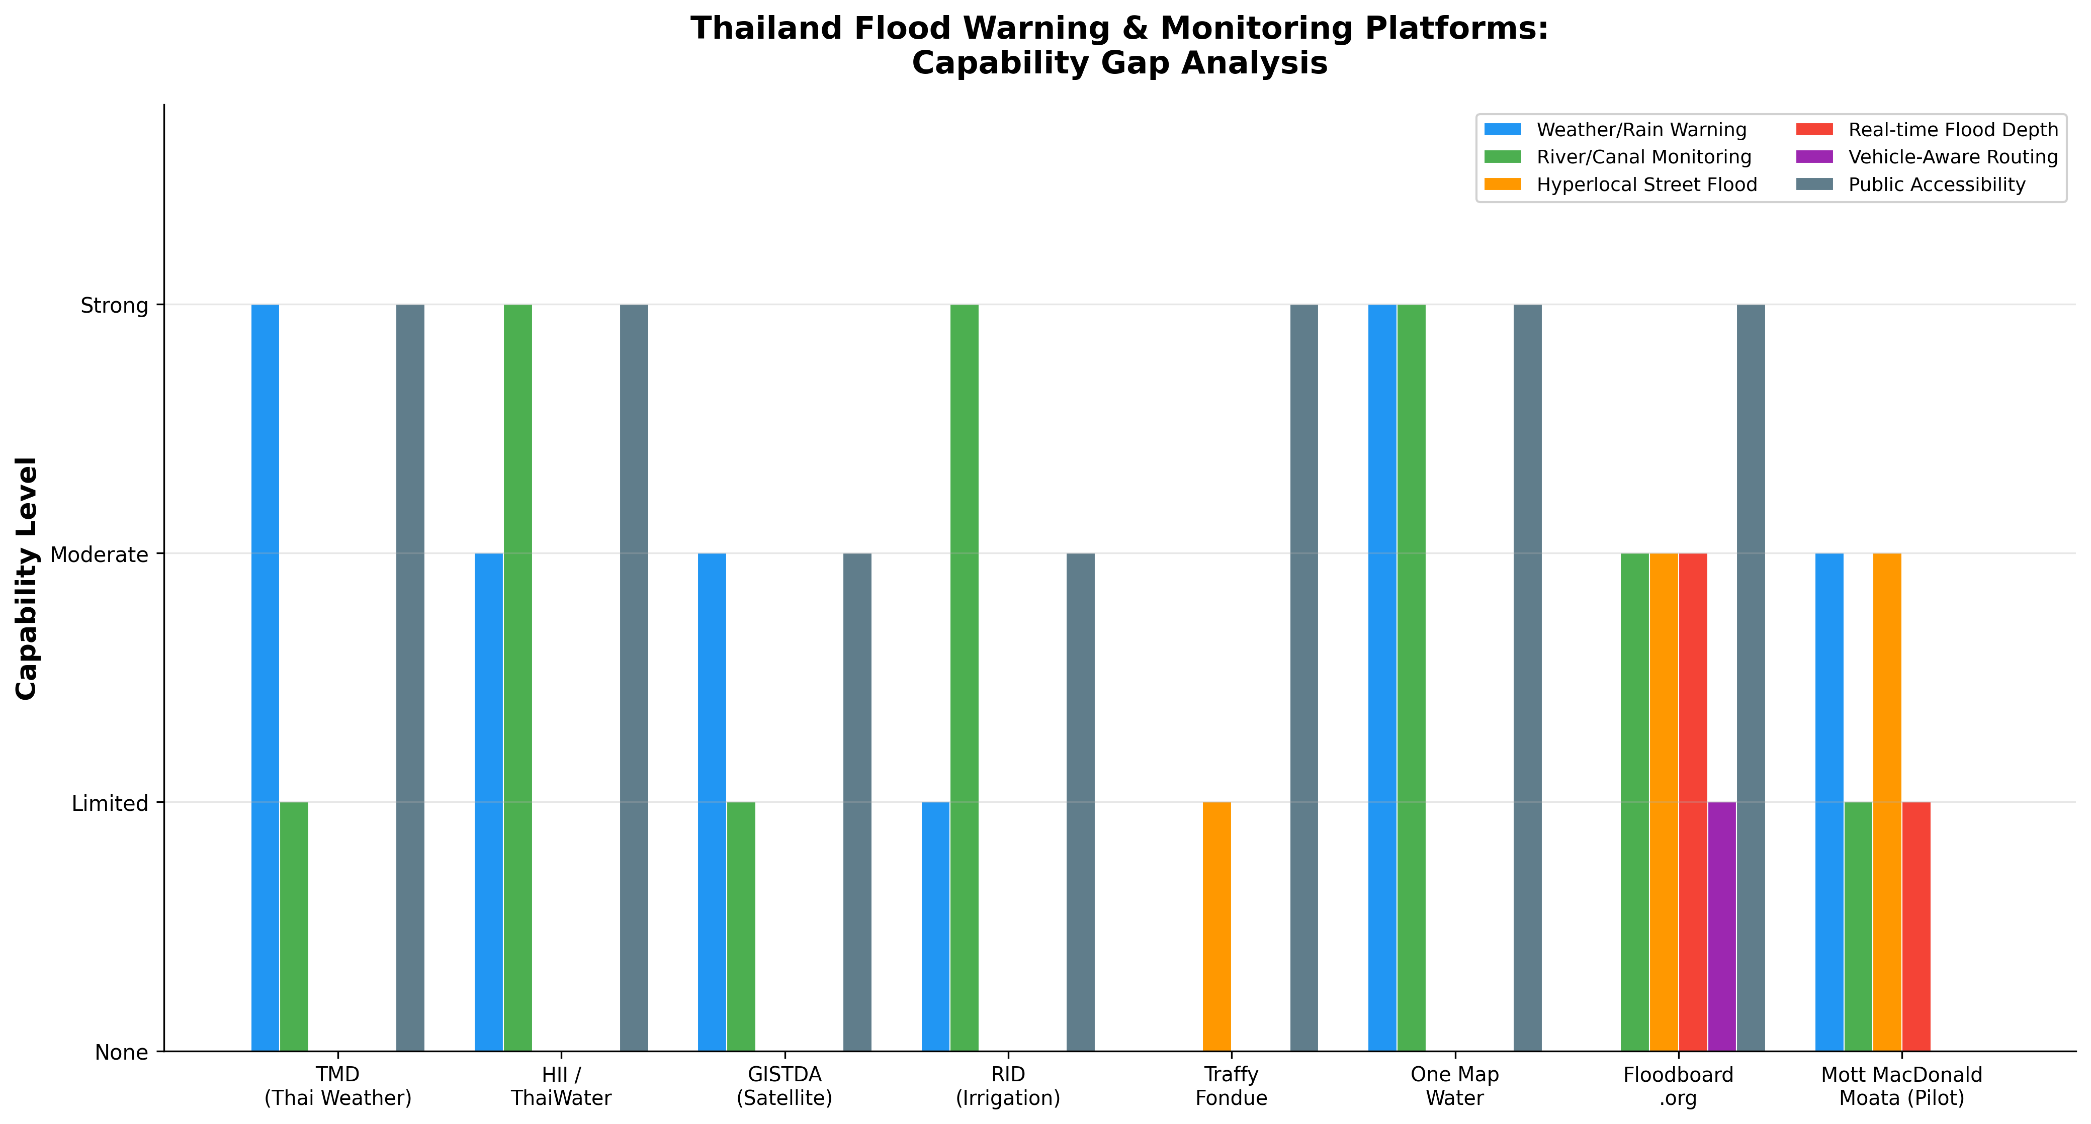
Thailand Flood Warning & Monitoring Platforms: Capability Gap Analysis
Chart Explanation: This chart compares eight Thai flood warning and monitoring platforms across six capability dimensions. The critical gap is visible in the “Hyperlocal Street Flood,” “Real-time Flood Depth,” and “Vehicle-Aware Routing” categories, where nearly all platforms score “None” or “Limited.” Only Floodboard.org offers partial vehicle passability information [3], and only the Mott MacDonald pilot approaches real-time urban flood prediction [17] — neither provides the centimeter-resolution, vehicle-type-aware routing that the D2C Mesh envisions.

Hyperlocal Flood Detection and Vehicle-Aware Routing Gap
The most significant technical white space for the D2C Mesh lies at the intersection of street-level flood detection and dynamic vehicle routing. Floodboard.org represents the closest existing Thai solution, aggregating data from BMA road-flood sensors, ThaiWater canal levels, Traffy Fondue citizen reports, Highway Department data, and CCTV feeds into a real-time map showing flooded road segments with depth in centimeters and vehicle passability ratings for sedans, motorcycles, and pickups [3]. However, Floodboard relies entirely on aggregated secondary data sources rather than its own sensor network or predictive models, limiting its ability to provide advance warning or cover areas without existing sensor infrastructure.
Globally, the FloodMapp and Waze integration represents the frontier of flood-aware navigation. Deployed as a pilot in Norfolk, Virginia, FloodMapp combines tidal, riverine, and rainfall data to generate rapid real-time flood inundation models at one-meter resolution, which are automatically layered with the city’s road network via GIS and transmitted to Waze for pop-up and audio alerts during navigation [19]. This integration is not available in Thailand. FloodRoute, a US-based application, combines live NOAA tide data with USGS elevation data to predict road-level flooding risk [20], but is similarly limited to the American market.
A critical finding from a 2026 research paper confirms that no operational system globally currently provides real-time, street-level flood depth information at the centimeter resolution required for dynamic routing, electric vehicle safety, and autonomous vehicle operations [21]. In Thailand specifically, neither Google Maps nor Longdo Map incorporates real-time flood data into routing algorithms. A prototype project, Bangkok 3D Flood Watch, demonstrates the technical feasibility of integrating BMA sensors, ThaiWater data, and Traffy Fondue reports into a three-dimensional visualization [22], but this remains a GitHub demonstration project without navigation engine integration. The D2C Mesh platform’s proposed approach — fusing multiple Thai public data APIs with AI elevation models to generate vehicle-type-aware flood routing — would occupy a genuinely uncontested market position.

Global Decentralized Disaster Relief and E-Voucher Platforms
The humanitarian sector has developed increasingly sophisticated digital platforms for disaster relief distribution, offering valuable architectural lessons for the D2C Mesh’s e-voucher track. The following table summarizes the leading global platforms and their key characteristics.
Platform | Technology Stack | Scale Achieved | Distribution Model | Key Lesson for D2C Mesh
WFP Building Blocks | Private Ethereum blockchain | 6.3M households; 159 organizations [8] | Blockchain accounts per household; iris-scan authentication | Neutral shared ledger prevents $324M in duplicate aid [8]; cut transaction costs up to 98% [23]
Stellar Aid Assist | Stellar blockchain; USDC stablecoin | $4.6M to ~2,500 households in Ukraine [24] | Digital wallets via SMS; MoneyGram cash-out within ~3 minutes [25] | Low-cost transfers work for unbanked populations
Oxfam UnBlocked Cash | Ethereum; Sempo + ConsenSys; NFC cards | ~1,000 people in Vanuatu [9, 26] | Blockchain-backed vouchers at local vendors via tap-and-pay | Vendor integration is critical for last-mile delivery [9]
GiveDirectly | Mobile money (M-Pesa); MobileAid platform | 200,000+ households across 15+ countries [27] | Fully remote enrollment; unconditional cash via mobile money | Speed: 18 days from zero presence to 2,108 families served [28]
Mercy Corps | Celo blockchain; HesabPay; smart contracts | 86,000+ families in Afghanistan [29] | Crypto transfers via HesabPay wallets; anticipatory payments | Blockchain enables transfers where banking infrastructure has collapsed [29]
UNICEF | Traditional + blockchain exploration | 3.5M households across 48 countries [30] | Mixed digital disbursement | Intermediary costs remain a major challenge at scale [30]
Table: Global Decentralized Disaster Relief Platforms — Technology and Scale Comparison
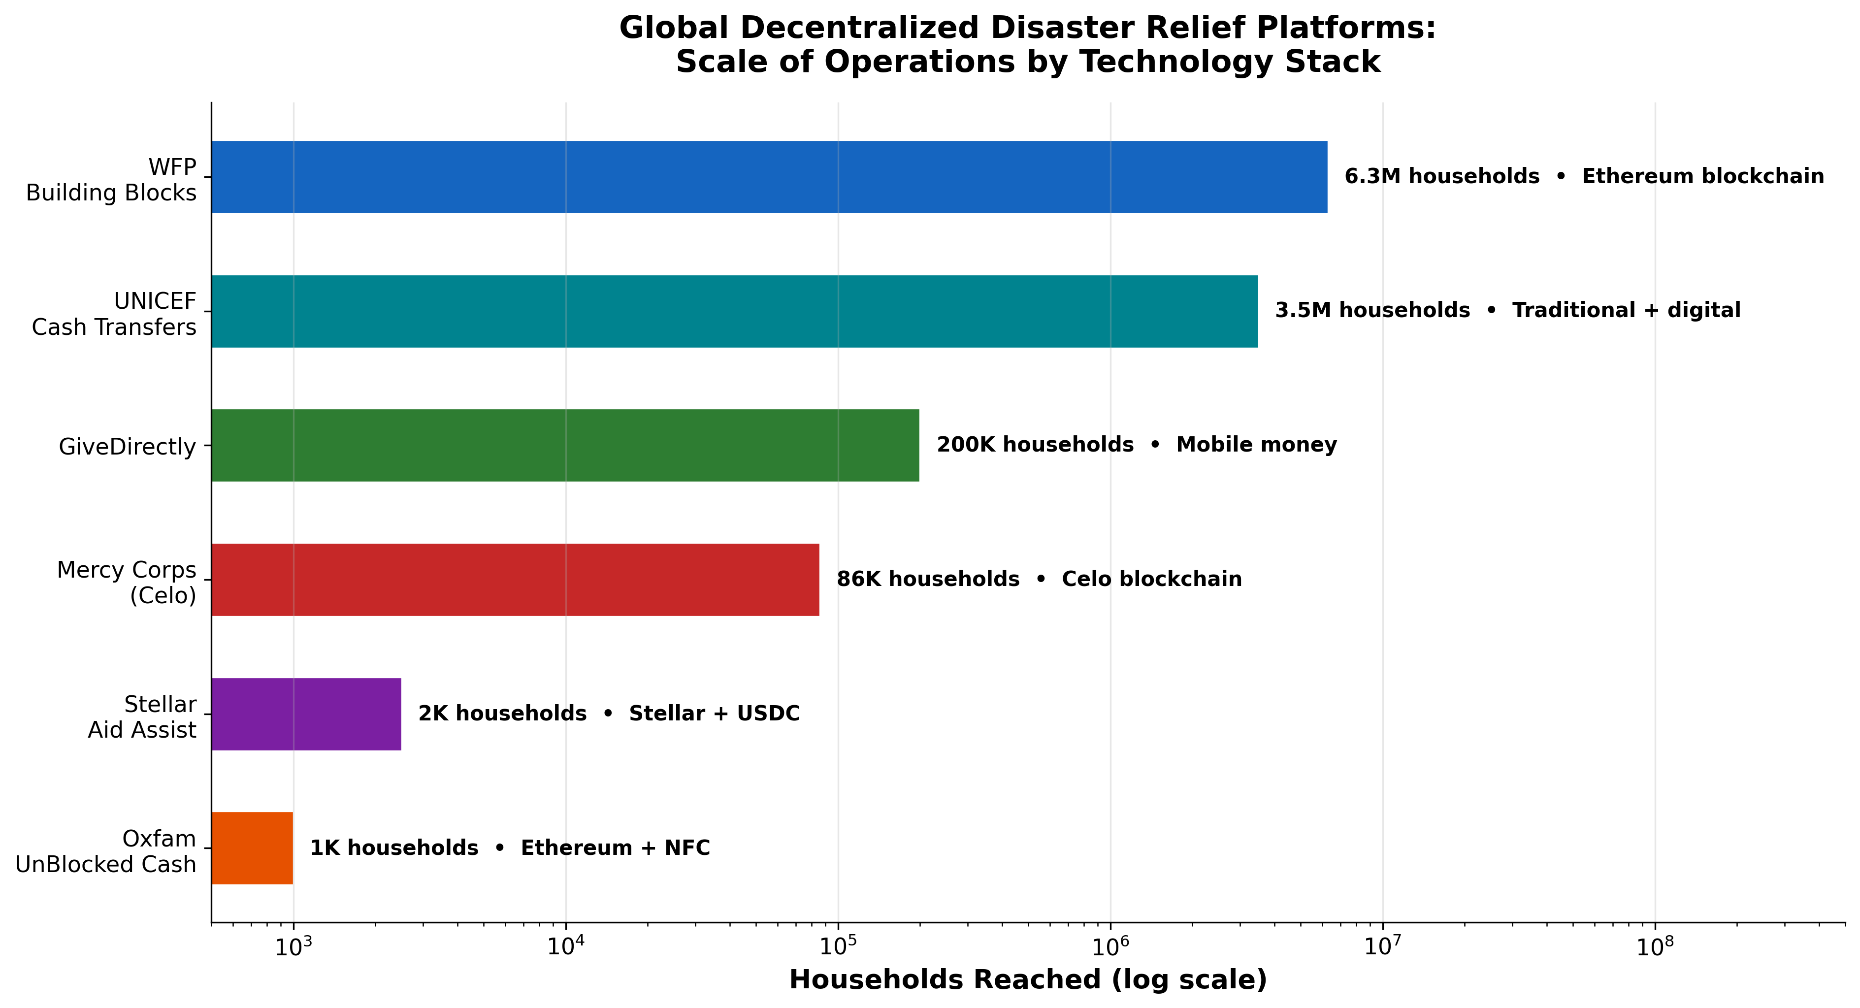
Global Decentralized Disaster Relief Platforms: Scale of Operations
Chart Explanation: This chart illustrates the vast range in operational scale across global decentralized relief platforms, from Oxfam’s 1,000-person pilot to WFP Building Blocks’ 6.3 million households [8]. The technology stacks range from private Ethereum blockchains to simple mobile money transfers, with the most scalable solutions (WFP, GiveDirectly) leveraging either blockchain coordination layers or existing mobile money infrastructure rather than building entirely new payment rails [23, 27].
The key lessons for the D2C Mesh are threefold. First, platforms that integrate with existing local vendor and payment networks — as Oxfam’s UnBlocked Cash did with NFC tap-and-pay at local stores [9] — achieve stronger last-mile delivery than those requiring new infrastructure. Second, speed of deployment is a decisive competitive factor, as GiveDirectly demonstrated by reaching 2,108 families in Madagascar within 18 days of a cyclone in a country where it had never previously operated [28]. Third, interoperable digital identity systems, as championed by the IFRC’s DIGID consortium, are essential for cross-agency coordination and fraud prevention [31].
Thailand’s current disaster relief model stands in stark contrast to these global innovations. The Thai government relies on direct bank transfers via the Government Savings Bank (GSB), having disbursed 5.225 billion baht to over 683,286 households across 46 provinces as of October 2026, with 9,000 baht per household [32]. An additional 10.5 billion baht ($313 million) was approved by cabinet for flood relief [33]. Digital innovation is limited to the registration layer: flood victims register via the “Thang Rat” mobile app or web portal, which links to the civil registry database for real-time verification, eliminating the need for police reports [34, 35]. No blockchain-based, decentralized, or voucher-based disaster relief platform exists in Thailand — the country’s PromptPay infrastructure and GSB banking network serve as the sole digital payment rails for government disaster disbursements.

Thai Government Digital Welfare Infrastructure
Thailand possesses one of Southeast Asia’s most advanced digital welfare distribution ecosystems, built on three pillars that collectively create both opportunities and constraints for the D2C Mesh platform.
PromptPay serves as the foundational payment rail. Owned by National ITMX Co., Ltd. and overseen by the Bank of Thailand, PromptPay is a real-time payment system supporting transfers via mobile number, citizen ID, tax ID, or bank account number [13]. As of 2025, the system had over 83 million registered users and processed transactions worth 54 trillion baht — more than twice Thailand’s GDP [36]. The network connects 28 banks directly and 6 of 29 non-bank wallets indirectly [37]. PromptPay’s significance for the D2C Mesh is that it has already achieved the universal merchant acceptance that humanitarian platforms in other countries struggle to build: according to the Emerging Payments Association of Asia, QR code payments are “embedded into daily life — from large retailers to street vendors, acceptance is near universal” [4], and PromptPay processes over 74 million transactions daily [5].
Khon La Khrueng (คนละครึ่ง) and the Paotang App represent the government’s proven co-payment distribution mechanism. Delivered through Krungthai Bank’s Paotang digital wallet, the program amassed over 40 million users during the COVID-19 era [6]. The latest iteration, “Thai Chuay Thai Plus,” provides a 60% government subsidy capped at 200 baht per day and 1,000 baht per month, usable at participating merchants between 06:00 and 23:00 via the Paotang app [38]. This model — where government funds flow through a digital wallet to be spent at verified local merchants — is architecturally analogous to the D2C Mesh’s proposed e-voucher system, providing a proven template for the platform’s design.
The Welfare Smart Card (บัตรสวัสดิการแห่งรัฐ) targets low-income citizens with monthly benefits including 300 baht for essential consumer goods at designated Blue Flag stores [39]. Phase 1 of the 2024 digital wallet scheme disbursed 10,000 baht to approximately 12.4 million welfare card holders and 2.1 million disabled persons [13]. Critically, the 2026 registration round requires e-KYC verification [40], and new welfare card holders must now link PromptPay accounts to receive funds [41] — signaling the government’s consolidation toward PromptPay as the universal welfare payment rail.
The อปท. gap represents the D2C Mesh’s most compelling integration opportunity. Thailand’s approximately 7,800 Local Administrative Organizations (LAOs) have fiscal autonomy under the 1999 Decentralization Act [10], but no standardized digital payment platform exists at the municipal level for local welfare voucher distribution. While Krungthai Bank’s Paotang app serves as the exclusive government digital wallet for national programs [42], Krungthai now offers an Open API portal with App-to-App authentication enabling third-party applications to integrate with Paotang accounts [7]. This creates a technical pathway for the D2C Mesh to serve as the digital disbursement layer for อปท. welfare budgets — filling a gap that neither Krungthai nor any other platform currently addresses.

SME Commerce Infrastructure and the Welfare-to-Commerce Bridge
The viability of the D2C Mesh’s “Micro-Relief Station” concept — where local SMEs serve as supply redemption points during disasters and community commerce hubs year-round — depends on the existing digital commerce readiness of Thai small merchants. The evidence is strongly favorable. According to the Bank of Thailand’s 2023 SME Payment Behavior Survey, 96% of SMEs had prior experience with e-payments, with e-payment values reaching 68% of total payment value [43]. Thailand has approximately 3.25 million SMEs constituting 99.5% of all enterprises, with the majority being micro enterprises in wholesale, retail, and services [44]. National QR standards through PromptPay have made merchant acceptance “nearly free for small merchants, which is why street vendors and hawker stalls take digital payments across the region” [45].
Platform ecosystem coverage extends deep into semi-urban areas relevant to the Nakhon Pathom pilot. LINE MAN operates with over 520,000 participating shops across all 77 provinces and more than 266 districts, reporting a 93% survival rate for technology-enabled small shops [46]. The e-commerce landscape is dominated by Shopee, TikTok Shop, and Lazada, which together cover over 90% of the Thai market [47]. Notably, Shopee has pledged over 500 million baht to support Thai MSMEs under the government’s “Thai Chuay Thai” co-payment scheme [48], demonstrating that the welfare-to-commerce bridge is already being built by major platforms.
The critical insight for the D2C Mesh is that the infrastructure gap which typically blocks Cash and Voucher Assistance (CVA) to commerce transitions in other countries — merchant digital payment acceptance — has already been largely closed in Thailand by PromptPay’s universal QR adoption [4, 49]. The platform does not need to build new payment rails or onboard merchants to a new system; it needs to create the coordination layer that connects disaster events to voucher activation to merchant redemption, all flowing through existing PromptPay QR infrastructure.

Market Gaps and Strategic Positioning
The synthesis of findings across all four research tracks reveals three distinct white-space opportunities and a clear competitive positioning for the D2C Mesh platform.
White Space 1 — Hyperlocal Street-Level Flood Detection. Despite Thailand’s substantial investment in national monitoring infrastructure, the State Audit Office findings that nearly three-quarters of flood incidents occur without prior warning [2] and that almost half of at-risk villages lack warning stations demonstrate a fundamental coverage failure at the community level. The D2C Mesh’s proposed approach of fusing TMD radar, HII telemetry, GISTDA satellite data, RID canal levels, and Traffy Fondue crowdsourced reports with AI elevation models could generate hyperlocal flood predictions for areas currently invisible to the national system. No existing platform — including the newly launched One Map Water — provides this capability [1, 16].
White Space 2 — The Warning-to-Action Pipeline. Research on last-mile early warning systems in Thailand’s Chiang Rai province found that preparedness and response capacity was the weakest pillar of existing systems, and that warnings often fail not because they are absent but because people cannot act on them in time [50]. The D2C Mesh’s integration of flood warnings with vehicle-aware routing and geo-targeted relief voucher activation creates a complete warning-to-action chain that no existing solution offers. Currently, a flood victim must check TMD for weather warnings, consult Floodboard or social media for road conditions, navigate without flood-aware routing, and then separately apply for government relief through the Thang Rat app — a fragmented process involving multiple agencies and manual handoffs.
White Space 3 — อปท.-Level Digital Welfare Distribution. With approximately 7,800 LAOs possessing fiscal autonomy but no dedicated digital disbursement platform [10], the D2C Mesh’s year-round community commerce mode — distributing อปท. welfare vouchers through PromptPay-integrated QR redemption at local merchants — addresses a structural gap in Thailand’s decentralization architecture. The government’s consolidation toward PromptPay as the universal welfare rail [41] and Krungthai’s Open API availability [7] create a viable technical integration pathway.
Key Barriers and Mitigation Strategies. The platform faces four primary barriers. First, Bank of Thailand e-money licensing requirements apply to any entity operating payment or voucher services, necessitating either direct licensing or partnership with a licensed financial institution. Second, government flood sensor and hydrological data remain siloed across DDPM, RID, and HII with no standardized open API, requiring individual data integration agreements. Third, flood-affected rural areas face network disruption precisely when warnings are most critical, demanding offline-capable architecture with mesh networking or SMS fallback. Fourth, the State Audit Office found that 41.90% of the public still receives disaster information via community leaders rather than digital apps [2], meaning the platform must incorporate community relay mechanisms — such as designated local coordinators at Micro-Relief Stations — rather than relying solely on smartphone-based delivery.

Recommendations for the D2C Mesh Platform
Based on this market research, the D2C Mesh platform should pursue a strategy of integration over invention — leveraging Thailand’s mature digital payment infrastructure rather than building parallel systems. The platform should route all financial transactions through PromptPay QR rails, which already achieve near-universal merchant acceptance [4, 5], and explore Krungthai’s Open API portal for Paotang wallet integration [7] to enable seamless interoperability with existing government welfare programs.
For the Nakhon Pathom pilot, the platform should prioritize demonstrating the warning-to-action pipeline as its core differentiator: a single user experience that detects rising flood risk through fused public API data, alerts affected residents with actionable routing guidance, and simultaneously activates geo-targeted e-vouchers redeemable at pre-registered local merchants. This integrated flow — which no existing Thai or global platform provides — represents the strongest competitive moat and the clearest value proposition for hackathon judges, government partners, and potential users alike.
The year-round sustainability model through อปท. welfare voucher distribution addresses the critical challenge facing all disaster-response platforms: maintaining user engagement and merchant participation between disaster events. By serving as the digital disbursement layer for local government welfare budgets during non-flood seasons, the D2C Mesh can maintain its merchant network, user base, and operational infrastructure in a state of continuous readiness — transforming from a seasonal emergency tool into permanent community commerce infrastructure.

References
1. https://en.mgronline.com/politics/government-launches-one-map-water-to-consolidate-disaster-warning-data-for-real/
2. https://wgea.org/wp-content/uploads/formidable/2/state_audit_office_proposes_strategic_upgrades_to_early_warning_system_to_maximize_public_safety.pdf
3. https://www.floodboard.org/
4. https://emergingpaymentsasia.org/wp-content/uploads/2026/05/Market-Intelligence-Access-Project-Payments-in-Thailand.pdf
5. https://www.paymentology.com/blog/why-thailand-is-ready-for-autonomous-payments
6. https://arxiv.org/pdf/2405.05086.pdf
7. https://developers.krungthai.com/
8. https://www.wfp.org/innovation
9. https://www.oxfam.org/en/unblocked-cash-project-using-blockchain-technology-revolutionize-humanitarian-aid
10. https://so04.tci-thaijo.org/index.php/TRESP/article/download/249321/169381/878155
11. https://play.google.com/store/apps/details?hl=en-US&id=com.tmddev.thaiweather
12. https://en.thairath.co.th/lifestyle/tech/2962132
13. Source: wikipedia.org
14. https://play.google.com/store/apps/details?hl=en&id=com.swoc.pr2025
15. https://doi.nrct.go.th/ListDoi/Download/652988?Resolve_DOI=10.14456/scitechasia.2024.32
16. https://www.straitstimes.com/asia/se-asia/bangkok-floods-put-thailands-new-one-map-warning-system-under-scrutiny
17. https://www.mottmac.com/en-us/projects/bangkok-smart-flood-management/
18. https://www.mdpi.com/1424-8220/26/11/3512
19. https://www.norfolk.gov/CivicAlerts.aspx?AID=5878&ARC=11318
20. https://apps.apple.com/us/app/floodroute/id6757653475
21. https://arxiv.org/abs/2603.17108
22. https://github.com/Ton-Munoi99/bangkok-flood-watch-3d
23. https://innovation.wfp.org/project/building-blocks
24. https://stellar.org/blog/foundation-news/stellar-aid-assist-2-year-anniversary?
25. https://www.bloomberg.com/news/videos/2024-10-01/stellar-s-use-in-refugee-aid-shows-crypto-purpose-dixon-video
26. https://www.oxfam.org.au/blog/instant-aid-with-blockchain/
27. https://www.givedirectly.org/kenya-climate-crisis-2026
28. https://www.givedirectly.org/madagascar-fytia
29. https://www.nytimes.com/2026/01/24/world/asia/crypto-innovation-afghanistan.html
30. https://www.unicef.org/innovation/stories/how-blockchain-can-transform-humanitarian-cash-transfers-scale
31. https://interoperability.ifrc.org/2021/05/19/digital-ids-in-the-humanitarian-sector-whats-the-big-deal/
32. https://www.chiangraitimes.com/finance/thailands-flood-relief-reaches-683286-homes/
33. https://www.yahoo.com/news/world/articles/thailand-cabinet-approves-313-million-071733209.html
34. https://en.thairath.co.th/news/society/2963702
35. https://en.thairath.co.th/news/local/bangkok/2963428
36. https://en.mgronline.com/economy/wittai-reveals-thai-promptpay-scan-to-pay-and-transfer-transactions-exceed-54-tr/
37. https://bfaglobal.com/wp-content/uploads/2022/08/Highlights-emerging-from-Thailand.pdf
38. https://en.thairath.co.th/news/society/2936515
39. https://en.thairath.co.th/news/society/2961029
40. https://en.thairath.co.th/news/society/2956440
41. https://www.thaipbs.or.th/verify/en/content/17198
42. https://stripe.com/au/resources/more/digital-wallets-in-thailand
43. http://www.bot.or.th/content/dam/bot/documents/en/research-and-publications/research/payment-research/2023_Survey_on_SMEs_Payment_Behavior.pdf
44. https://www.oecd.org/en/publications/financing-smes-and-entrepreneurs-2026_bb7fc5c4-en/thailand_82ede51e-en.html
45. https://gr4vy.com/posts/payment-methods-in-southeast-asia-a-market-by-market-guide/
46. https://en.thairath.co.th/money/tech_innovation/digital_transformation/2961067
47. https://note.com/anymindgroup/n/n75cc4480a32e?hl=en
48. https://www.msn.com/en-xl/news/other/shopee-promotes-scheme-to-assist-small-merchants/ar-AA27ajUK
49. https://plan-international.org/emergencies/cash-voucher-assistance/
50. https://media.sciltp.com/articles/2604003747/2604003747.pdf

